Shelter’s Advertising Campaign

The below article, which Shelter released as a response to the government cuts in 2010, explores how Shelter plans to help the homeless. Read it through. Highlight and make notes around the side of the article of anything that they plan to do. What do they think about the cuts? What is the tone of the article? What is the article saying?

Shelter launches new ad campaign to drive people to seek advice earlier
Housing and homelessness charity Shelter has launched a new advertising campaign to encourage people facing housing problems to seek earlier advice. The campaign aims to tackle a common reluctance to do this: a recent study found that 50% of people do not seek external advice when they encounter housing difficulties. (Civil and Social Justice Panel Survey (2010))
The main focus of the activity is a series of poster ads. Each one depicts an ordinary person in distress because they are facing a serious crisis, such as sudden job loss or mounting debt. They carry a single headline which shares with the viewer the desperation the person is feeling. The aim is for the combined impact of the headline and image to resonate with people experiencing these problems and tap into their concerns, driving them to seek advice on Shelter’s website.
Early advice can be crucial in helping people with housing issues find a positive outcome for their problem. The ad campaign aims to highlight its importance, as well as demonstrating how people can seek help.
The campaign was created by Amplify on a pro bono basis. The poster campaign will initially launch in four towns which have been identified as hotspots for housing problems, and will run from 21 August for six weeks. Advertisements will also run on Facebook and mobile messaging.
Impact will be measured by tracking traffic to the website, and by monitoring attitudes to housing in the towns where the ads will run.
Kay Boycott, director of campaigns, policy and communications at Shelter, said: “In these tough economic times, more and more people across the country are struggling to keep their heads above water and are in desperate need of our help.
“50% of people don’t seek external advice when they encounter housing problems, so our priority in this campaign is to increase the number of people coming to us for help and reaching a positive outcome.
“Visitors to our online advice pages have increased by over a third in the last year (37% increase from 2008/09 to 2010/11), proving that there’s a growing demand for digital guidance. We hope the campaign will have a significant impact in showing people who have been hit by difficult times that help is just a click away, while raising the profile of housing issues further.”
Jonathan Emmins, Founder of Amplify said: "Amplify is best known for being a creative comms agency specialising in non-traditional media and channels, so it has been great working with Shelter on a brief to create cut-through in a more traditional advertising space. It was crucial to us that the creative had the ability to shock and stand out but without resorting to gimmicks. We wanted people to empathise, to never lose sight of the real people, the real faces impacted by the current economic and housing situation."
Shelter’s Advertising Campaign

For each advert, analyse and make notes on:

- Advertising Techniques
- ASA:
  - The guidelines surrounding charity adverts
  - The ‘ideal victim’ / ‘positive vs negative’ campaigns
- Media Language:
  - Shot type
  - Camera angle
  - Lighting
  - Framing
  - Composition
  - Facial expressions
  - Body language
  - Colours
  - Props
  - Costumes
  - Typography
  - Logos
  - Text
  - Model used
- Representation:
  - What is being represented (event/issue/individual/social group)
  - Stereotypes
  - Positive/negative representations
  - The effect of the social, cultural and political context on these representations
  - The way in which representations make claims about realism
- Social Context:
  - How the government cuts have impacted on the advertising campaign
  - How Shelter have responded to the government cuts
- Evaluative personal response:
  - Strengths and weaknesses
  - Personal opinion
  - How far is the advert successful in communicating its message to the audience?

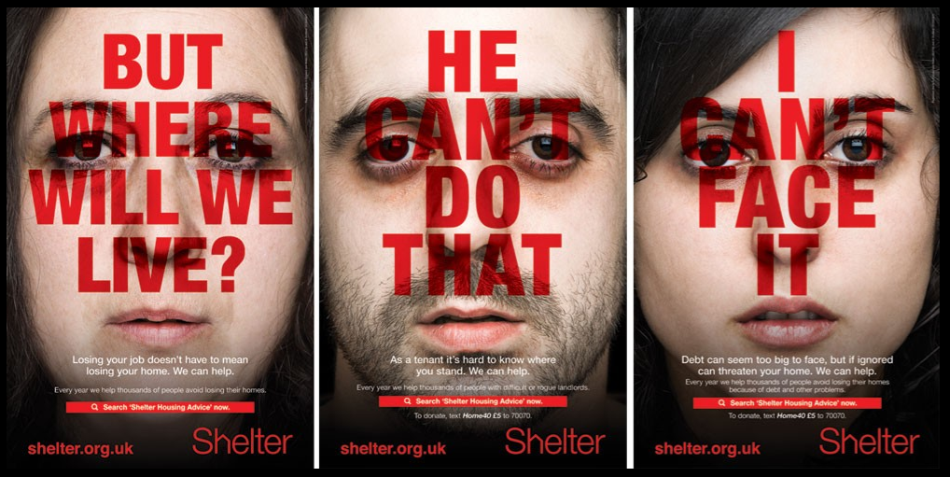
Colour of text – Intense red associated with pain, danger & anger
Close up image of their face – almost like their personal problems are being exposed
Variety of situations and people – Loss of job, debt etc. different genders and ethnicity implies that these issues can impact anyone.
Helpless expression makes the viewer sympathise
Inclusive pronoun ‘we’ targets the viewer as part of the story

Seeks to inform people who might not realise they can find help in their situation.
Big bold text in capitals to solidify that there is a problem with what the landlord is doing that can be punished.
‘We can help’ encourages the viewer to seek help and that Shelter will be successful in helping them.
Disappointed/annoyed expression might make someone in a similar situation realise they can get help and there are others in the same situation.

Debt is a common problem that can overwhelm people, the ad tells them they don’t have to fix the problem alone and they can find help
Serious expression, again the close up shows it’s an issue that people might find personal and not want to talk about even though they know they need help.

Explain how representations are created in the Shelter advertisement to promote the charity. (10)
The representation of housing problems as a temporary, solvable issue creates the idea that help is available to you when you are in need and at a low point, in these advertisements it is shown that anyone of any gender or background can be affected by housing issues. Shelter shows the viewers of these adverts that it is okay to ask for help when you are struggling, no matter what the situation is. These advertisements show that it is better to ask for help sooner rather than later, for example it says that debt should not be ignored and will only get worse if you don’t seek help before the problem only grows and becomes more overwhelming.
The bold, capitalised text conveys that these problems are important and prominent in the life of the person affected, telling the viewer that these issues need to be solved as soon as possible. The red of the font could also be associated with pain, anger and suffering to imply that these problems can only bring suffering if they are left unsolved. Red can also sometimes be associated with willpower, possibly showing that it takes a lot of will to ask for help but it is one of the only ways to solve these problems.
Close ups are used for each image of a person, giving an up close and personal view of their face and possibly presenting to the viewer that these issues are personal and it is difficult to be vulnerable and ask for help in these situations but it is necessary to do so. These advertisements are tailored to encourage those struggling with housing issues to seek help through shelter and convince them that seeking help can solve their problems if they put the initial effort in to get the help. Shelter seeks to show people that help is ‘just a click away’ and not as difficult to find as it may seem – with the adverts encouraging people to seek advice on the charity’s website. In a very technology centred world, providing an online source of aid is likely the best way to reach a wide variety of people and offer aid.
Alongside finding new people in need of help, the campaign also garners sympathy from the general public and inspires people to donate to Shelter to allow them to offer better service and help to those who need it, the advertisements create sympathy towards people who are struggling with these problems.

